**CRICKET MANAGEMENT**

**SYSTEM**

Submitted in partial fulfillment of the requirements

of the degree

**BACHELOR OF ENGINEERING**

**IN INFORMATION TECHNOLOGY**

By

**Aryan Sawant** **21101A0008**

**Vishal Devkate** **21101A0019**

**Vishal Mourya** **21101A0024**

**Shivraj Pawar** **21101A0017**

Supervisor

Prof. **Rasika Ransing**



**Department of Information Technology**

**Vidyalankar Institute of Technology**

**Vidyalankar Educational Campus,**

**Wadala(E), Mumbai – 400 037**

**University of Mumbai**

**(AY 2022-23)**

**CERTIFICATE**

This is to certify that the Mini Project entitled “**CRICKET MANAGEMENT SYSTEM** ” is a bonafide work of **Aryan Sawant (21101A0008), Vishal Devkate (21101A0019), Vishal Mourya (21101A0024), Shivraj Pawar (21101A0017)** submitted to the University of Mumbai in partial fulfillment of the requirement for the award of the degree of “**Bachelor of Engineering**” in “**Information Technology**” .

**Prof. Rasika Ransing**

Supervisor

**Dr. Vipul Dalal Dr. S.A.Patekar**

Head of Department Principal

**MINI PROJECT APPROVAL**

This Mini Project entitled “**CRICKET MANAGEMENT SYSTEM** “by **Aryan Sawant (21101A0008), Vishal Devkate (21101A0019), Vishal Mourya (21101A0024), Shivraj Pawar (21101A0017)** is approved for the degree of **Bachelor of Engineering** in **Information Technology**.

**Examiners**

**1**……………………………………………….

(Internal Examiner Name & Sign)

**2**……………………………………………….

(External Examiner Name & Sign)

Date:

Place: Mumbai

**Contents**

**Abstract Acknowledgments**

**List of Figures**

**1 Introduction**

1.1 Introduction

1.2 Motivation

1.3 Problem Statement & Objectives

1.4 Organization of the Report

**2 Literature Survey**

2.1 Survey of Existing/Similar System

2.2 Limitation Existing/Similar system or research gap

2.3 Mini Project Contribution

**3 Proposed System**

3.1 Introduction

3.2 Architecture/ Framework

3.3 Algorithm and Process Design

3.4 System Architecture

3.5 Details of Hardware & Software

3.6 Experiment and Results

3.7 Conclusion and Future work

**References**

**ABSTRACT**

**Cricket Management System** is a project which aims in developing a computerized system to maintain all the daily records of Cricket This project has many features which are generally not available in normal Cricket management systems like facility of user login and a facility of admin login. It has a facility of admin login through which the admin can monitor the whole system. It has also a facility where user after logging in their accounts can see list of player details, team details, date and time of each match and coach details. The admin after logging into his account. Admin’s account can able to add or remove team details, match details, coach details, umpire details.

## 

## **Acknowledgments**

We wish to express our gratitude to **Vidyalankar Institute of Technology** for their guidance and constant supervision as well as for providing us with all the necessary information regarding the project. We are also very thankful to respected **Prof. Rasika Ransing** of department of **Information Technology** of **VIT** whose help, stimulating suggestions and encouragement helped us in completing this project successfully.

**List of Figures**

1. ER Diagram……………………………………………………………………………………………………11
2. Welcome Tab………………………………………………………………………………………………….14
3. User Tab…………………………………………………………………………………………………………..15
4. All Teams…………………………………………………………………………………………………………15
5. Players Tab………………………………………………………………………………………………………16
6. Top 10 Batsmen/Bowlers………………………………………………………………………………...16
7. Matches Tab, View all matches……………………………………………………………………….17
8. Search by TeamID…………………………………………………………………………………………..17
9. Search Match by Date……………………………………………………………………………………18
10. Other Info Tab…………………………………………………………………………………………………19
11. Admin Tab……………………………………………………………………………………………………….20
12. Schedule Matches Tab…………………………………………………………………………………….20
13. Reschedule Match Button……………………………………………………………………………….21
14. Update Result………………………………………………………………………………………………….21
15. Disqualify Tab………………………………………………………………………………………………….22
16. Modify Data Tab ...….……………………………………………………………………………………….22
17. Modify Data2 Tab……………………………………………………………………………………………23

**Chapter 1**

**Introduction**

### **1.1 Introduction**

A Cricket management is a project that manages and stores players information electronically according to player's needs. The system helps both players and admin to keep a constant track of all the players available in the team. It allows the admin to track team records.

The project titled “CRICKET MANAGEMENT SYSTEM” is a comprehensive system which provide all the information about World cup. This project deals with the scheduling matches,, updating their results ,disqualifying a player or a team and adding ,updating ,deleting of data related to worldcup by an authorized person.

### **1.2 Motivation**

In India there are many people including our project team who are very interested in Cricket than anything else. Cricket World Cup is the tournament for which Cricket fans are very much excited. Therefore we decided to create a GUI where anyone can get any information they

want about world cup. To make the life of the one who maintains data we also decided to implement features like scheduling matches etc. It would be really helping both Cricket fans and also the team which maintains the data.

## **1.3 PROBLEM STATEMENT AND OBJECTIVES**

This project aims to design and implement the database to maintain the data related to Cricket World Cup.

The The main objective of this system is to reduce the consumption of time during maintaining

the

records of Cricket Club Management System. Separate divisions are provide to

maintain the records of Cricket club, faculty, Roots, diversion, etc.

→ User-friendly interface.

→ Interactive design.

→ No professional knowledge required

→ System will have maintained club as well as player record

The main objective of this system is to reduce the consumption of time during maintaining

the

records of Cricket Club Management System. Separate divisions are provide to

maintain the records of Cricket club, faculty, Roots, diversion, etc.

→ User-friendly interface.

→ Interactive design.

→ No professional knowledge required

→ System will have maintained club as well as player record

The objectives of our project of Cricket World Cup database management system are:

* Systematic storage of all the data and try to avoid the redundancy
* Using the basic concepts of database management system
* To thoroughly study the concepts and applications of database systems while implementing
* Properly making use of the database design concepts to implement the system
* Using *structured query language* for implementation

**1.4 Organization of the Report**

I. Introduction

- Purpose of the report: To document the design and development of a Python GUI using PyQt5, SQLite, Qt Designer, and VSCode.

- Background information on Python GUI development: Brief overview of Python GUI development and the advantages of using PyQt5, SQLite, Qt Designer, and VSCode.

II. Design and Planning

- Discussion of the project requirements: Explanation of the project requirements, including the user interface, database schema, and functionality.

- Description of the system architecture: Overview of the system architecture, including the use of PyQt5 for the front-end and SQLite for the back-end.

- Discussion of the design patterns and frameworks used: Explanation of the design patterns and frameworks used in the development of the system, including the Model-View-Controller (MVC) pattern and the PyQt5 framework.

III. Implementation

- Explanation of the implementation approach: Discussion of the development approach used, including the use of VSCode as the integrated development environment (IDE) and the use of Git for version control.

- Description of the development process and tools used: Overview of the development process, including the creation of the user interface in Qt Designer and the implementation of the back-end in Python using SQLite.

- Discussion of the testing and validation process: Explanation of the testing approach used, including the use of unit testing and integration testing.

IV. User Interface

- Description of the user interface design: Overview of the user interface design, including the wireframes, mockups, and style guide.

- Overview of the user experience and interactions: Explanation of the user experience and interactions with the system, including the user flow and user feedback mechanisms.

- Discussion of the accessibility and usability features: Explanation of the accessibility and usability features implemented in the system, including support for different screen sizes and keyboard navigation.

V. Database Design and Implementation

- Explanation of the database schema: Overview of the database schema used in the system, including the tables, fields, and relationships.

- Description of the database implementation: Overview of the database implementation, including the use of SQLite and the Python SQLite library for accessing and manipulating data.

VI. Deployment and Maintenance

- Explanation of the deployment process: Overview of the deployment process used, including the creation of a standalone executable using PyInstaller and the installation of the required libraries and dependencies.

- Overview of the maintenance and support plan: Discussion of the maintenance and support plan for the system, including the backup and recovery procedures and the issue resolution process.

- Discussion of the future enhancements and upgrades: Explanation of the possible future enhancements and upgrades for the system, including the implementation of additional functionality and the use of other libraries and frameworks.

VII. Conclusion

- Summary of the report: Recap of the key points covered in the report.

- Reflection on the project outcomes: Discussion of the lessons learned during the project and the challenges faced.

- Recommendations for future improvements: Suggestions for improving the system in the future, based on the findings and experiences gained during the project.

**Chapter 2**

**LITERATURE SURVEY**

### **2.1 LITERATURE REVIEW**

A Cricket Management System is a tool which a library using the old way to manage it in any institution can use and increase their work efficiency. The old method of searching for a team and providing the same to the player through manual work is a real hassle and hinders fast report generation. This software provides a central database maintained for every important record such as player history, match history and the happenings in the team and is organized systematically. This system is helpful for any institution or organization such as engineering, legal, medical, schools, colleges, corporate houses, research centres and many more. There are many papers published and researches done in this area and we have learned the idea for a library system. Some of the paper works and their ideas are as follows:

Any team who want to participate in the tournament should register their team’s name, members name, phone number, email to the server, and then the user can login with the username and password in the login form and can view the tournament details. The website details are monitored by administrator and the match allotment is allotted by admin. Admin will able to track records of players, teams. Admin will also track records match and coach details.

Online Cricket Management System, is a software developed in python focusing on the basic operations of a teams including adding player details, adding team details, adding coach details, adding match details updating any data of players performed for a team.

Enhanced Cricket Management System has been designed to overcome the problem of existing system to provide the feasible solution to the user. It has some features which makes it different from normal Cricket management system like it consists of three modules:

Admin module, Player module.

It is developed to manage the daily activities of a team in an efficient way.

The Tournament date time and the

venue are savedin the database for further information. All the player’s detail will be displayed.

The Tournament date time and the

venue are savedin the database for further information. All the player’s detail will be displayed.

The Tournament date time and the

venue are savedin the database for further information. All the player’s detail will be displayed

### 

### **2.2 LIMITATION EXISTING/SIMILAR SYSTEM RESEARCH GAP**

1. **Lack of Customization:** Our Cricket management systems are rigid and do not allow customization to meet the specific needs of different Cricket teams or leagues.

2. **Limited Functionality:** Some Cricket management systems provide only basic functionalities, such as recording scores and managing player profiles, while neglecting other critical features such as scheduling and managing matches, player availability, team selection, and so on. i.e. we cannot add the particular new data into the database but shows only a popup message.

**Research Gap:**

There is a lack of research on our Cricket management systems, especially in the context of developing countries where Cricket is highly popular. Most of the research has been done on Cricket analytics and statistics rather than on developing comprehensive Cricket management systems.

Moreover, there is a need for research on the integration of emerging technologies such as Artificial Intelligence (AI), Machine Learning (ML), and Internet of Things (IoT) to improve the efficiency and effectiveness of Cricket management systems.

Additionally, there is also a lack of research on the integration of social media and other online platforms to enhance the communication and engagement between players, fans, and other stakeholders involved in Cricket management.

**2.3 MINI PROJECT CONTRIBUTION**

A Cricket management system is a project that manages and stores player information electronically according to team’s needs. The system helps admin to keep a constant track of all the players available in the team. It allows the admin and to search for the desired team. It becomes necessary for teams to keep a continuous check on the player records. This task if carried out manually will be tedious and includes chances of mistakes.

This application will not only be available for the Cricket team selection committee but also for the general public. Anybody with some interest in Cricket will find the application useful as each player can be analysed and the stats of players can view in a graphical way for easy understanding.

The stats of players in these Cricket teams will be available to the user along with the analysis. Using them the user can select the best Cricket team line-up manually or can choose to automatically display the best Cricket team line-up that is computed by the application.

**Chapter 3**

**PROPOSED SYSTEM**

### **3.1 INTRODUCTION**

Cricket management system is a programming application and database connected system especially designed for staff members in an institution which eases the Cricket management in a more systematic and cost-effective manner. This project makes the entire Cricket management computerized for staff member so that they don’t have to work manually with the team.

* Firstly, from the application icon situated in the desktop, it introduces a login window.
* In the login window the admin will have to enter the valid login id and password, if in case the login id or the password.
* is not correct then it will prompt a message that it is an invalid id/password.
* If the user logins successfully then it will introduce him/her to the main window.

### **3.2 ARCHITECTURE/FRAMEWORK**

Users in this system:

* **Admin**
* **User**

**User functions**: view all Cricket team’s, tournaments, playing 11

* **Admin**: Add, view, and delete the player. Add coach and stadium details.
* **Login**:

It is clear with the name what this function is for. It enables the user and admin login. The first login would always be the admin login, and the password remains the same, i.e., admin.

After the admin login, one can perform various activities of the admin such as view teams view players in a team, view the stadium, add player, add team details,

View coach details. View match details, view ranking of each team, view match details, etc.

**Connect to GUI:**

As it says, this function connects the database to the GUI. After connecting the database, the username and password of the database have to be entered to start the function. Next, using the create function, database, tables, and data can be added to the table.

This is done with the help of SQL statements, which helps to connect to the GUI and enable login.

* User Menu: The user menu displays all the teams.

Admin Menu: The admin has all the permissions in the system and can perform functions like view teams view players in a team, view the stadium, add player, add team details, View coach details. View match details, view ranking of each team, view match details, etc.

* Output menu: The output menu will display the answers to the query. The initial id and password for the first login would be for admin, and the username and password would also be the same, i.e., admin.

Various options are as follows:

* View teams- When you click this option, the details of the team as stored in the team’s icon will be displayed with their name. This will display a table consisting of team id, country name.
* View Player – You can enter team id and get all players by clicking all players in a particular team.
* Add player – To add a new user to the program, click on ‘modify data’ and select whether it is an admin to continue. The details of all players will be displayed in the player section. After adding player details then message is box will display that the details of player is saved.
* View match details– After clicking of ‘Matches’ tab it will display match id, displaying team name and stadium id, result id, winning team.
* View coach details: Adding the coach details to the system can be done here with all the details of the coach id, coach name, etc. It can be viewed in the ‘view coach details’ section thereafter.
* View umpire details - Adding the umpire details to the system can be done here with all the details of the umpire id, umpire name, etc. It can be viewed in the ‘view umpire details’ section thereafter.

### **3.3 ALGORITHM AND PROCESS DESIGN**

We will focus on the following set of requirements while designing the Cricket Management System:

* Any user should be able to search team, players, match details.
* Each team will have a unique team id and other details including player details, match details, etc.
* The system should be able to retrieve information like player details, team details what are the teams checked-out by a specific user.

- The system should be able to find top batsmen, top bowler, top all-rounder.

* Before every match the system will able to predict best top 11 players including batsmen, bowler, all-rounder in a team.

- The system should be able to find result between two matches.

* The system will able to show timetable of each match.
* The admin will able to disqualify player in a team.

**3.4 System Architecture**

1) Team has Players (1:N)

A cricket player can play in only one team but a team can have many players in it but a team must have players in it.

2) Team is Managed by Coach(1:N)

Coach can manage a single team, but each team can have many coaches (like batting coach, fielding coach, bowling coach). But it is compulsory for a team to have a coach. So, the relationship is 1:N .

3) Team plays match(M:N)

Team can play many matches and a match can be played by two teams. So, the relationship is M-N.

4) Team has a rank in Points table(1:1)

5) Team has a Captain(1:1)

Each team lead by a single caption.

6) Matches are umpired by Umpire(M:N)

An umpire can umpire in many matches and a match can have two umpires. So, the relationship is M-N. Team headed by a Captain (1-1) A team has 1 captain and a captain is from single team only. So the relationship is 1-1.

7) Matches are played in a Stadium(N:1)

N matched can be done in a 1 stadium.

8) Match has a result(1:1)

9)A player is man of the match in match result(1:1)

10) A team is winner in match result.(1:1)

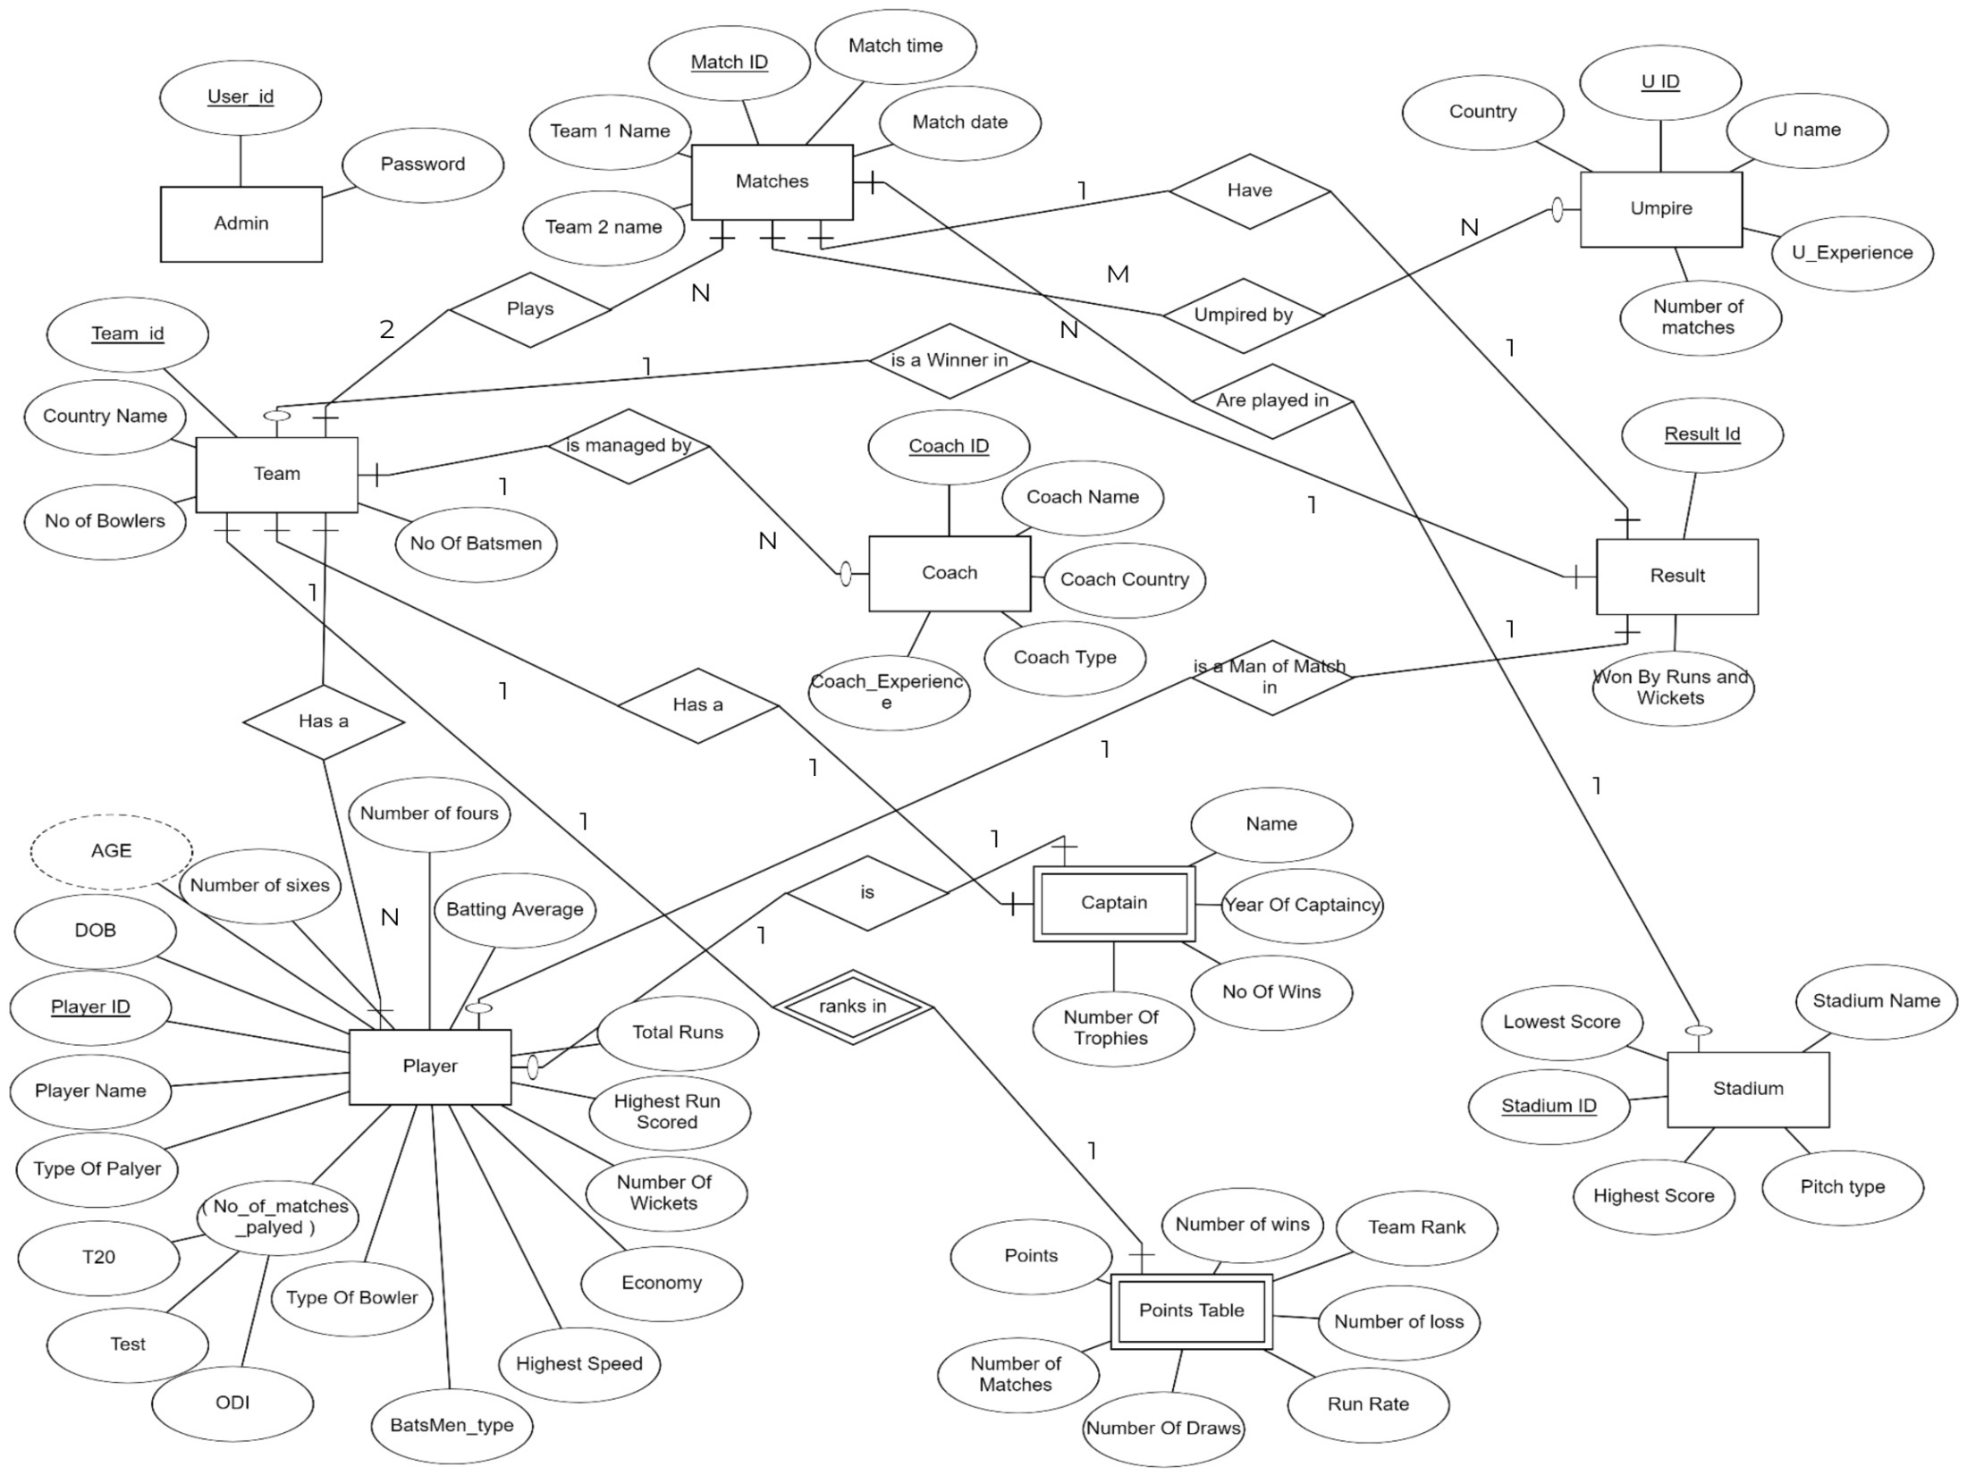

**Fig 1: ER Diagram**

If we consider Player table, player is either a batsman or bowler or all rounder Hence some values becomes null if player is only batsmen or only bowler.

Player { player id, player name, dob, type of player, no of tests, no of matches, team id, batsman type, number of sixes, number of fours, total runs, highest runs, batting average, bowler type, number of wickets, highest speed, economy }

To avoid null values Player table is further divided into 3 tables

* Player { player id, player name, dob, type of player, no of matches, team id }
* Batsman { player id, batsman type, number of sixes, number of fours, total runs, highest runs, batting average }
* Bowler { player id, bowler type, number of wickets, highest speed, economy }

### **3.5 DETAILS OF SOFTWARE AND HARDWARE**

**HARDWARE REQUIREMENTS**

* Intel core i5 2nd generation is used as a processor because it is fast than other processors an provide reliable and stable and we can run our pc for long-time. By using this processor, we can keep on developing our project without any worries.
* Ram 1 GB is used as it will provide fast reading and writing capabilities and will in turn support in processing

**SOFTWARE TOOLS USED**

* Details of Software:

**1)SQLite browser: -**

It is a tool that lets you view the data that is stored in an SQLite Database. Depending on the format and type of data in the database it may or may not be readable by a human. This is generally used for debugging or other development task where the developer needs to read the data that has been stored but does not have a built-in system to access it through the program.

**2)Visual Studio Code: -**

**Microsoft Visual Studio is Microsoft’s big and comprehensive IDE/compiler/debugger package for C# and C++ development that has been around for many years and is available for Windows and macOS (but not for Linux).** And, here’s the confusing bit: **Visual Studio Code has very little to do with Microsoft Visual Studio**. (Though, I would guess that they use a lot of common code under the hood.)

Visual Studio Code is an offering of its own, open source, not commercialized (for the time being at least), and based on Electron**. It doesn’t use the Atom editor component though, like many other development tools built with Electron.** Instead, it uses a separate editor component that is also used in Microsoft’s Azure DevOps product. This is not something you need to worry about, or even know, when working with Code, of course.

**3)QT Designer: -**

Qt Designer is a graphical user interface (GUI) design tool that comes with the Qt framework. It allows developers to create and edit GUI interfaces visually, without needing to write any code. Qt Designer makes it easy to create professional-looking and user-friendly interfaces for desktop applications.

With Qt Designer, developers can create GUI interfaces by dragging and dropping widgets onto a canvas, and then setting their properties and connecting them to signals and slots. It provides a wide range of built-in widgets and layouts, including buttons, labels, text boxes, check boxes, radio buttons, and many others.

Qt Designer also includes a preview feature, allowing developers to see how the GUI will look and behave before running the application. It also includes features for managing resources such as images and icons, and for creating custom widgets and plug-ins.

One of the benefits of Qt Designer is that it generates code automatically based on the design created by the developer. This code can then be integrated into the application's main codebase, saving time and effort in developing the user interface.

Overall, Qt Designer is a powerful and user-friendly tool for creating GUI interfaces for desktop applications. It simplifies the process of designing and coding user interfaces, making it easier and faster to create professional-looking and user-friendly applications.

**4) PyQT5 Module: -**

PyQt5 is a comprehensive set of Python bindings for Qt 5. It is implemented as a set of Python modules that wrap the original Qt C++ classes, making it easy to use Qt from Python.

Some of the key features of PyQt5 include:

- Support for a wide range of platforms including Windows, Linux, and macOS

- Full support for Qt's extensive set of widgets and tools

- Compatibility with both Python 2 and Python 3

- Easy integration with other Python libraries and tools

- A large community of developers and users who contribute to its ongoing development and support

Overall, PyQt5 is a powerful and versatile tool for creating desktop applications with Python and Qt. It provides a rich set of features and tools for building modern, cross-platform user interfaces that are both intuitive and visually appealing.

**3.6 Experiment and Results**

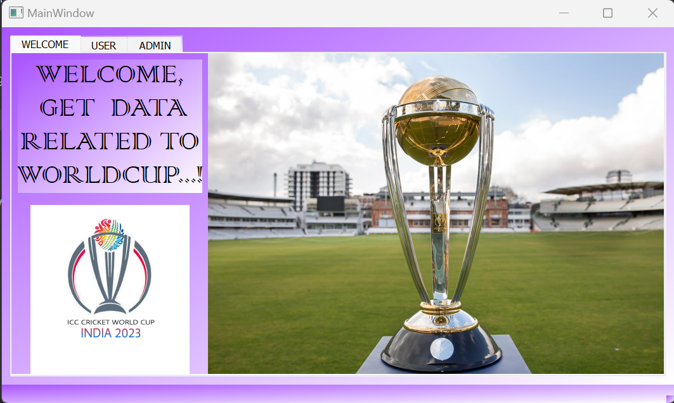

**Fig 2: Welcome Tab**

**1.USER  
Open Teams tab  
If you are a normal user you can get all details about Worldcup in the USER tab.**

### 

**Fig 3: User tab**

**You can click on each team icon to get that particular team details. You can click on All teams to get info of all teams.** 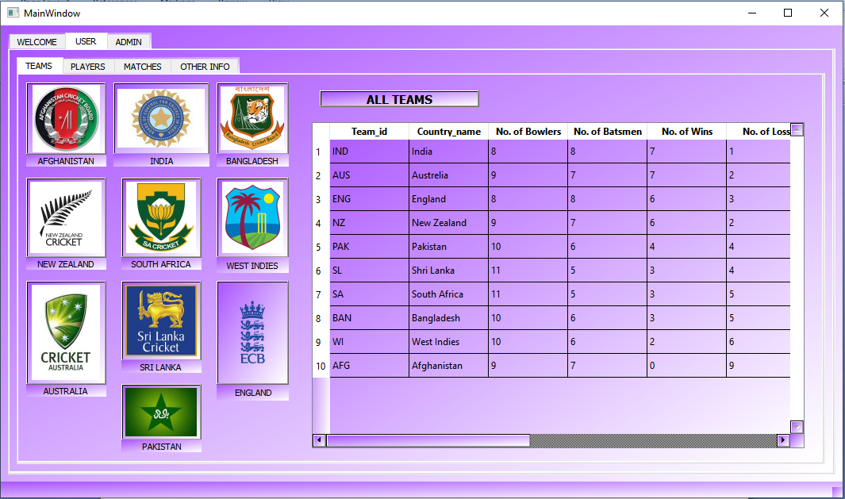

**Fig 4: All teams**

Open **Player** tab  
In player tab you can enter **team Id** and get all players by clicking **All players**,  
**Batsmen** and **Bowlers** of a particular team

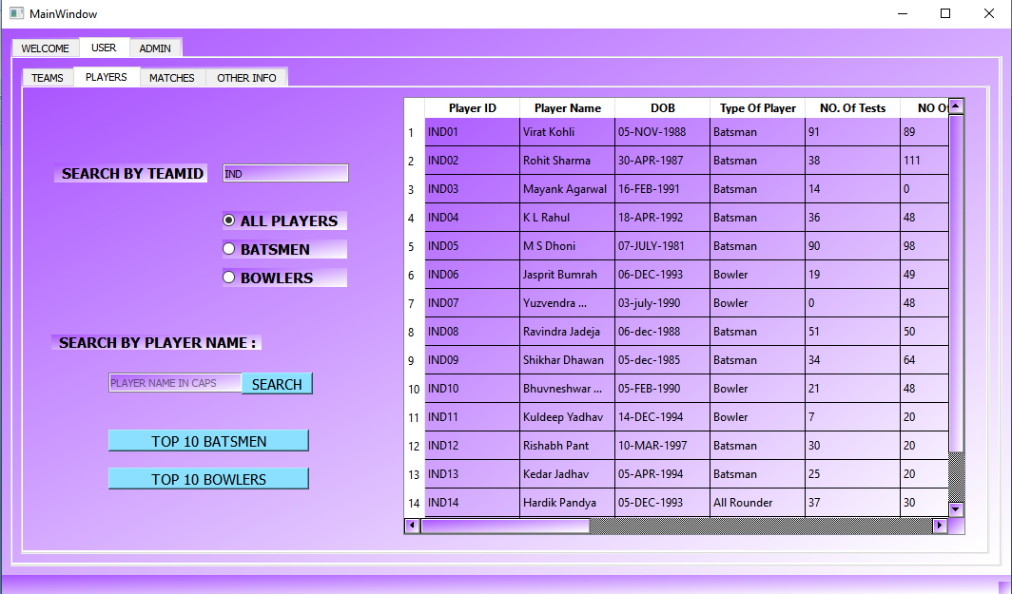

**Fig 5: Players Tab**

### **Get Top 10 batsmen of the tournament by clicking top 10 batsmen button.**

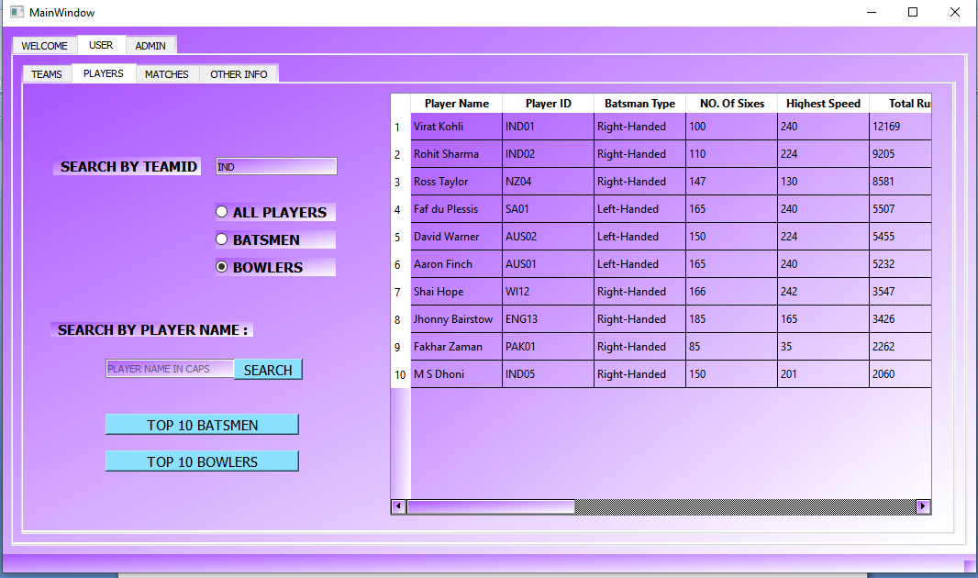

**Fig 6: Top 10 Batsmen/Bowlers**

**Get info of all matches by clicking display all matches.**

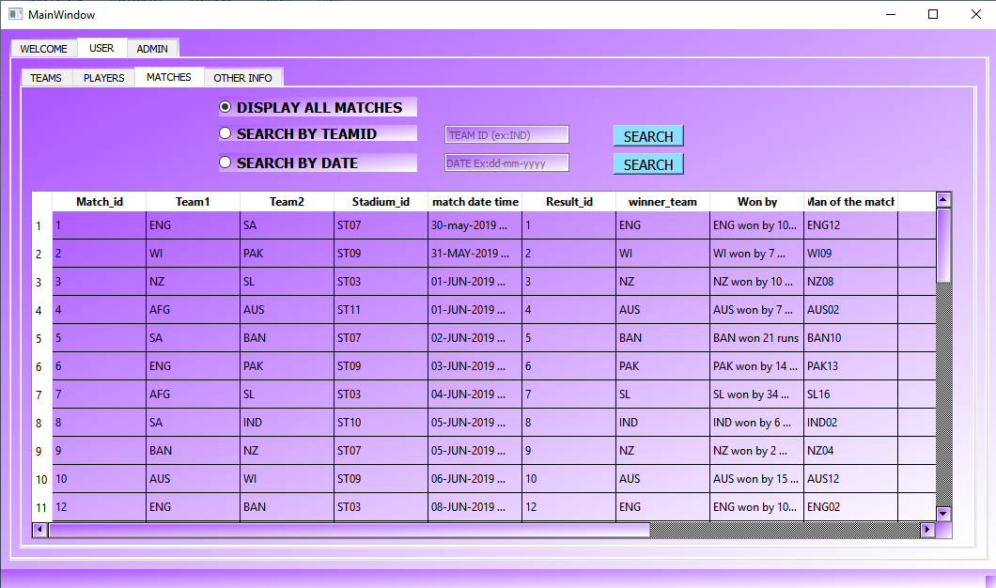

**Fig 7 : Matches Tab, View all matches**

### **Search your favorite team to check the information of matches and its result.**

### 

**Fig 8: Search by TeamID**

**Get match details of a specific date.**

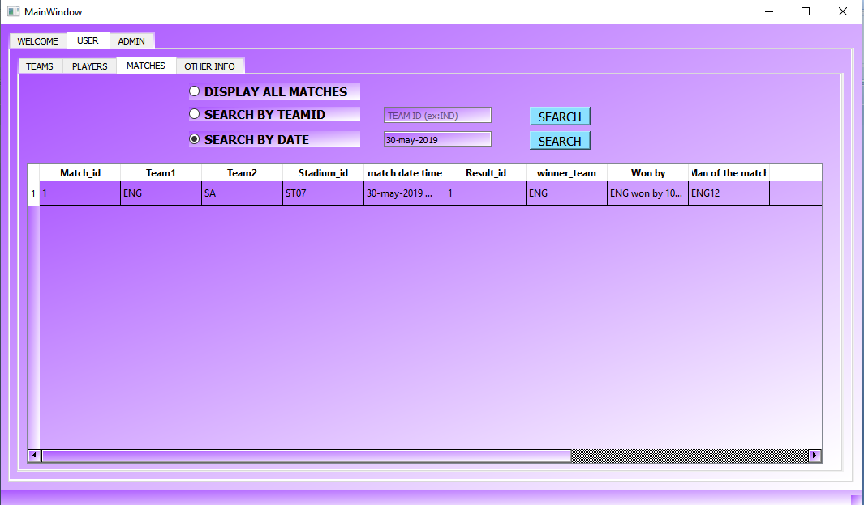

**Fig 9: Search Match by Date**

### **Open Other Info tab   click Display all captains , all coaches, umpire mapping to matches, all umpires, all stadiums to get respective information.**

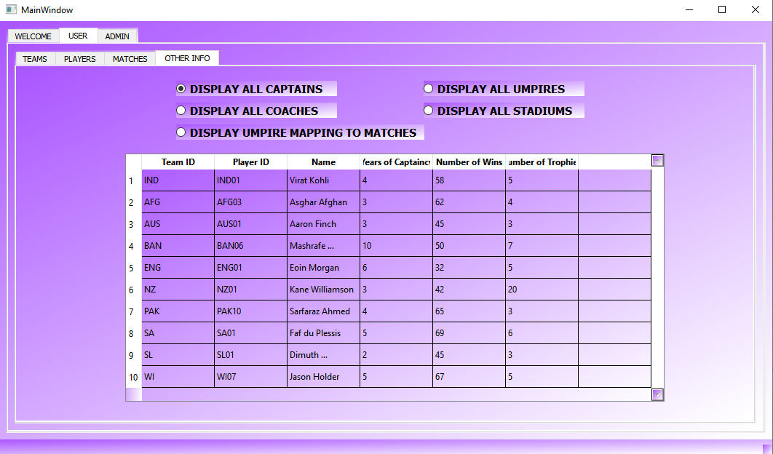

**Fig 10: Other info Tab**

**2.ADMIN**  
If you are admin enter your **username(savv)** and **password( savv8)** and click **Login.**   
Another window will open where all the admin activities can be done. 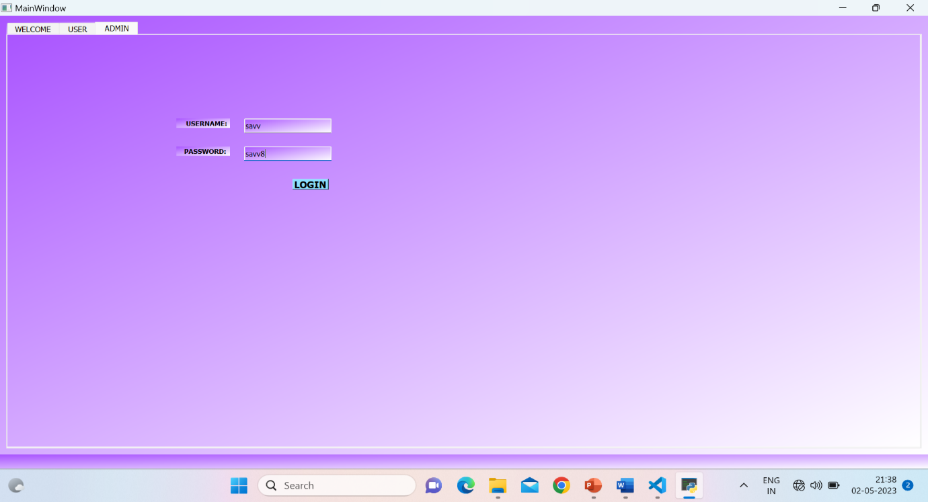

**Fig 11: Admin Tab**

Go to **SCHEDULE MATCHES** tab  
To schedule a match enter **Team ids** of both teams ,the date and time of match ,it’s venue(stadium) and 3 **umpires** who will umpire the matches  
Then click **schedule**. A confirmation message is displayed with match number  
Click **ok**.

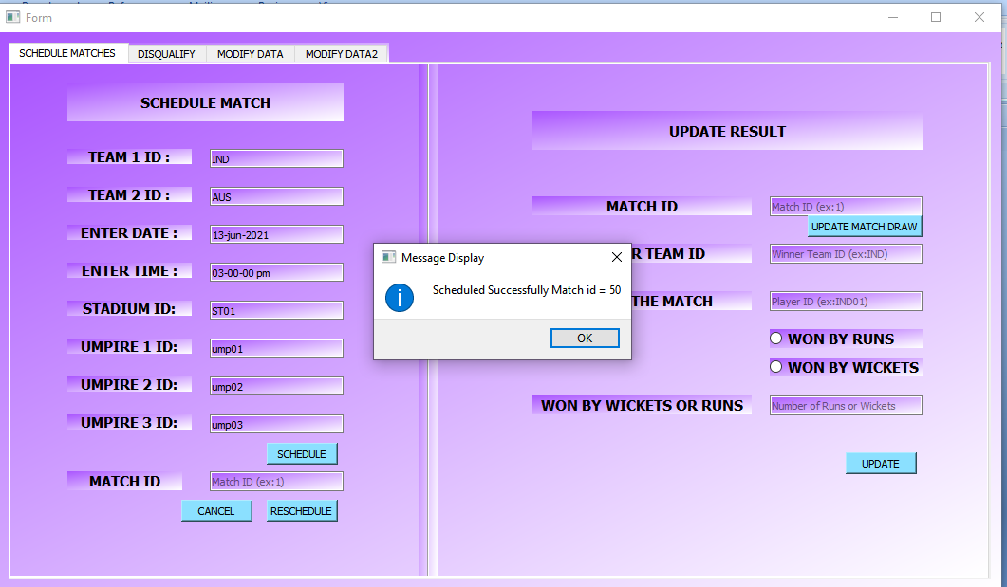

**Fig 12: Schedule Matches Tab**

### **To reschedule a match enter Match ID and date and time and click reschedule.**

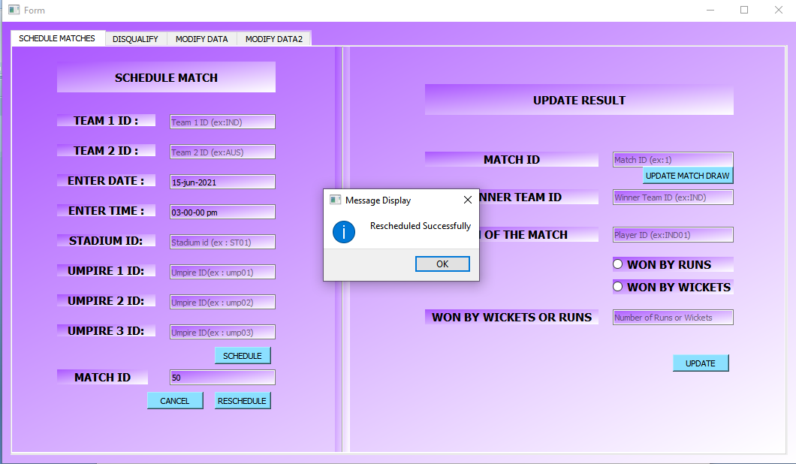

**Fig 13: Reschedule Match Button**

To update the result of a match enter it’s match ID if it is draw click on **update match draw** button. Otherwise enter winner team ID . Select whether they won match by **wickets** or **runs** select respective button.  
Enter number of wickets or runs in **Won by wickets** or runs.  
Click **update**. The result will be updated.

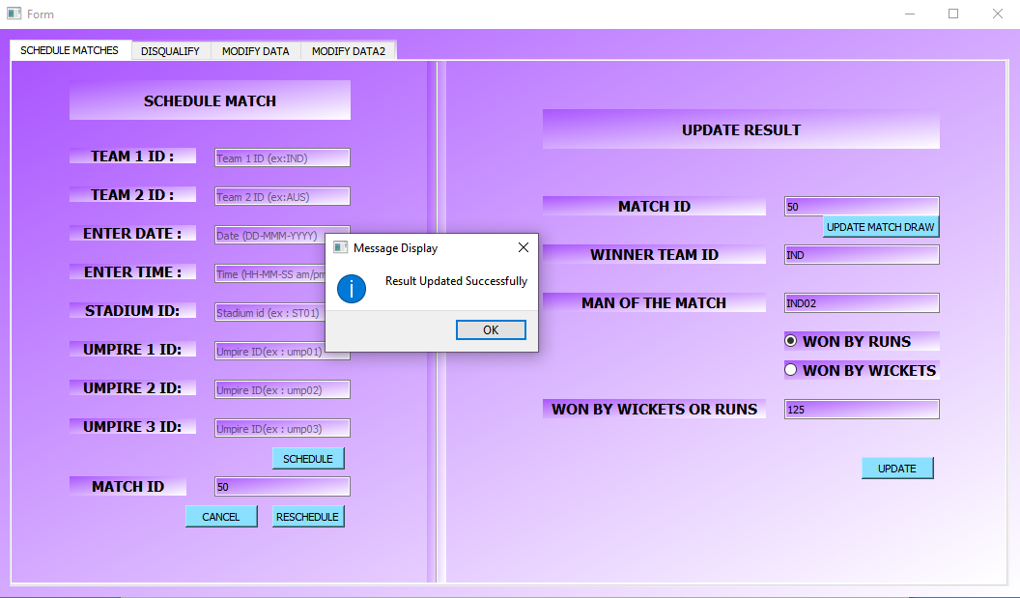

**Fig 14: Update Result**

**Go to DISQUALIFY tab  
Enter Player ID and click Go (that player will be disqualified).**

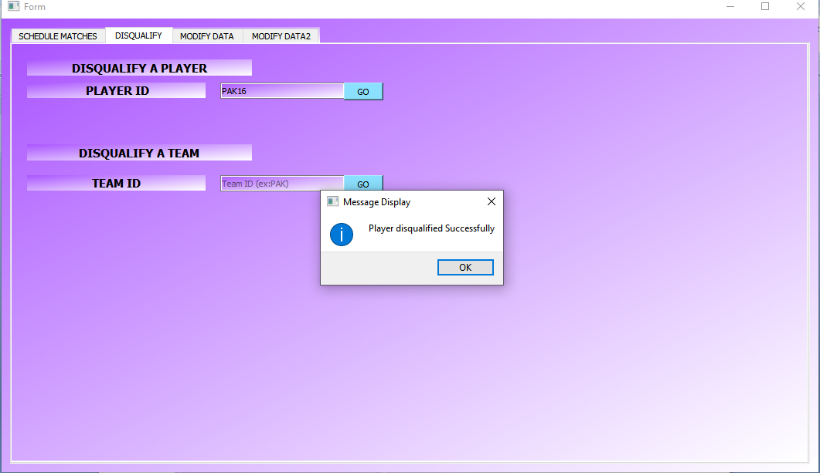

**Fig 15: Disqualify Tab**

**To add to, update or delete data from database.  
Enter the new values of new record to be added and click insert.  
A message box will be displayerd and your data will be saved. Like this batsmen, bowlers data can also be added modified or deleted.**

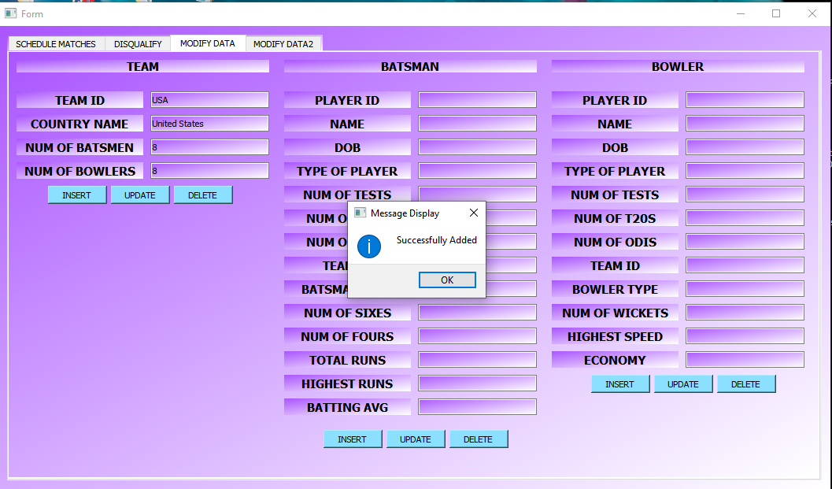

**Fig 16: Modify Data tab**

**Go to MODIFY DATA2 tab  
Here captains, stadiums, coaches, umpire data can be added modified or deleted like same way you have done to team data.**

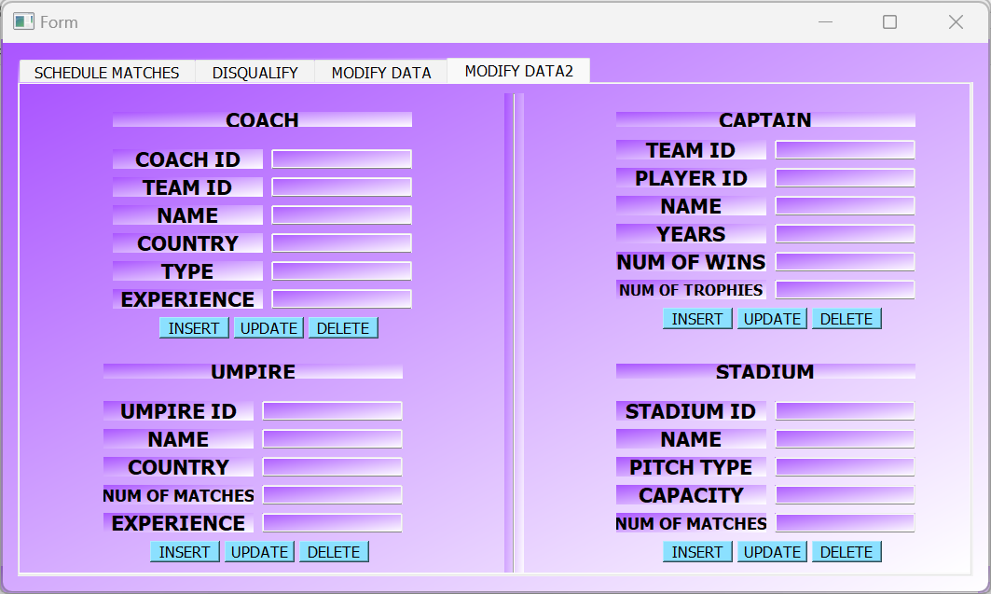

**Fig 17: Modify Data2 Tab**

**3.7 CONCLUSION AND FUTURE WORK**

In conclusion, a Cricket management system is an essential tool for teams, coaches, and fans to manage and analyze Cricket data effectively. It provides various features such as player statistics, live score updates, injury tracking, analytics and data visualization, scheduling and tournament management, and social media integration, to enhance the overall experience of the game. As the sport of Cricket continues to evolve, the need for advanced technology in managing and analyzing data will increase, and Cricket management systems will play a critical role in providing insights and strategic decision-making for teams and coaches. Ultimately, the success of a Cricket management system depends on its ability to accurately and efficiently provide relevant information to its users, and as such, its development should be continuously improved and updated to meet the needs of the sport’s stakeholders.

There are several potential areas for future work and improvement in a Cricket management system. Here are some possible suggestions:

1. **Enhanced player statistics:** Currently, most Cricket management systems provide basic player statistics, such as batting average and bowling average. In the future, these systems could be improved by providing more advanced statistics, such as strike rates, economy rates, and more detailed fielding data.
2. **Live score updates:** While many Cricket management systems provide live score updates, there is still room for improvement in terms of accuracy and speed. Systems could be improved to provide faster and more reliable updates, perhaps by integrating with live streaming services or using advanced data processing techniques.
3. **Player injury tracking:** Injuries are a common occurrence in Cricket, and it is important for team management to keep track of which players are injured and when they are likely to return to play. Future Cricket management systems could provide more advanced injury tracking and management features, such as automated alerts when a player's injury status changes.
4. **Analytics and data visualization:** Cricket generates a vast amount of data, and it can be difficult to make sense of all this information without the help of advanced analytics and data visualization tools. Future Cricket management systems could provide more powerful analytics and visualization features, such as heat maps and advanced predictive modeling.
5. **Integration with social media:** Social media has become a major part of the modern Cricket experience, and future Cricket management systems could be improved by integrating with social media platforms to provide real-time updates and analysis of social media activity related to Cricket.
6. **Improved scheduling and tournament management:** Scheduling and managing Cricket tournaments can be a complex and time-consuming task. Future Cricket management systems could provide more advanced scheduling and tournament management features, such as automated fixture generation and real-time tracking of scores and standings.
7. **Mobile app integration:** Many Cricket fans follow the game on their mobile devices, and future Cricket management systems could be improved by providing more advanced mobile app integration features, such as push notifications for live score updates and mobile-friendly data visualization tools.

Overall, there is significant potential for future work and improvement in Cricket management systems, and these systems will play an increasingly important role in the future of the sport

**References**

Razzaq, S., Sadiq, A., & Akbar, F. (2021). Development of a GUI based Cricket Management System using Python. In 2021 2nd International Conference on Computing, Mathematics and Engineering Technologies (iCoMET) (pp. 35-40). IEEE.